GitHub - sudheerj/angular-interview-questions: List of 300 Angular Interview Questions and answers
https://www.geeksforgeeks.org/angular-js/angular-interview-questions-and-answers/
How To Use Reactive Forms in Angular? - GeeksforGeeks

Pipes:

import { Component } from '@angular/core';

@Component({
selector: 'app-birthday',
template: `<p>Birthday is {{ birthday | date }}</p>`
})
export class BirthdayComponent {
birthday = new Date(1987, 6, 18); // June 18, 1987
}

Directive:
import { Directive, ElementRef } from '@angular/core';

@Directive({
selector: '[appHighlight]'
})
export class HighlightDirective {
constructor(el: ElementRef) {
el.nativeElement.style.backgroundColor = 'red';
}
}

<p appHighlight>Highlight me!</p>

What is the difference between pure and impure pipe?
A pure pipe is only called when Angular detects a change in the value or the parameters passed to a pipe. For example, any changes to a primitive input value (String, Number, Boolean, Symbol) or a changed object reference (Date, Array, Function, Object). An impure pipe is called for every change detection cycle no matter whether the value or parameters changes. i.e, An impure pipe is called often, as often as every keystroke or mouse-move.

What is the difference between Template-driven and Reactive Forms?
Template-driven Forms | Reactive Forms
Based on directives | Based on explicit creation
Asynchronous | Synchronous
Simple forms | Complex forms
Two-way data binding | Immutable data model

54. What are Angular Guards?
Angular Guards are services that control access to routes in an Angular application. They are used to protect routes from unauthorized access or to prevent unwanted navigation. Common types of guards include:
- CanActivate: Determines if a route can be activated.
- CanDeactivate: Checks if a route can be deactivated.
- CanLoad: Determines if a module can be loaded lazily.

Local Error Handling in Components/Services
import { HttpClient, HttpErrorResponse } from '@angular/common/http';
import { catchError } from 'rxjs/operators';
import { throwError } from 'rxjs';
// In your component or service
constructor(private http: HttpClient) {}
getData() {
this.http.get<any>('https://api.example.com/data')
.pipe(
catchError((error: HttpErrorResponse) => {
if (error.error instanceof ErrorEvent) {
// A client-side or network error occurred. Handle it accordingly.
console.error('An error occurred:' error.error.message);,
} else {
// The backend returned an unsuccessful response code.
// The response body may contain clues as to what went wrong.
console.error(
`Backend returned code ${error.status}, ` +
`body was: ${error.error}`);
}
// Return an observable with a user-facing error message.
return throwError(() => new Error('Something bad happened; please try again later.'));
})
)
.subscribe({
next: data => console.log(data),
error: err => console.error('HTTP Error:', err)
});
}

Local Error Handling in Components/Services
Import { catchError } from 'rxjs/operators';
import { throwError } from 'rxjs';
this.httpClient.get('https://api.example.com/data').pipe(
catchError(error => {
// Quality con
trol catches the problem
console.error('Delivery problem:', error);
// Send an apology note or fix the issue
return throwError(() => new Error('Oops! Something went wrong. Please try again later.'));
})
)
.subscribe(data => {
// Successful delivery
});

Observable Code:
Member Component :
getMembers() {
this.memberService.getAll().subscribe(response => {
this.members = response
}, error => {
console.log(error)
})
}
Member Service:
getAll(): Observable<Member[]>
{
Return this.http.get<Member []>
(`${environment.baseUrl}/Member/GetMembersList`);
}

Promise Code:
getMembersAsPromise(): Promise<Member[]> {
return this.http.get<Member[]>(this.apiUrl).toPromise();
}

//function code
this.memberService.getMembersAsPromise()
.then(data => this.members = data)
.catch(error => console.error('Error fetching members:', error));

Managing state in Angular without NgRx can be effectively achieved using a combination of Angular's built-in features and RxJS. The primary methods include:
- Services with RxJS Observables (e.g., BehaviorSubject):
  - Create a singleton service to hold and manage the application state.
  - Use a BehaviorSubject (or Subject, ReplaySubject) within the service to store the state. BehaviorSubject is often preferred as it immediately emits the current value to new subscribers.
  - Expose the state as a public Observable (e.g., using asObservable()) from the BehaviorSubject to prevent direct external modification.
  - Provide public methods in the service to update the state. These methods should modify the BehaviorSubject's value, which will then be emitted to all subscribers.
  - Components can inject this service and subscribe to the exposed Observable to react to state changes. The async pipe is recommended in templates for automatic subscription and unsubscription.
TypeScript
// user.service.ts
import { Injectable } from '@angular/core';
import { BehaviorSubject, Observable } from 'rxjs';
interface User {
name: string;
age: number;
}
@Injectable({ providedIn: 'root' })
export class UserService {
private userSubject = new BehaviorSubject<User>({ name: '', age: 0 });
user$: Observable<User> = this.userSubject.asObservable();
setUser(user: User): void {
this.userSubject.next(user);
}
getUser(): User {
return this.userSubject.getValue();
}
}

- Define the Model Interface (Optional but Recommended):

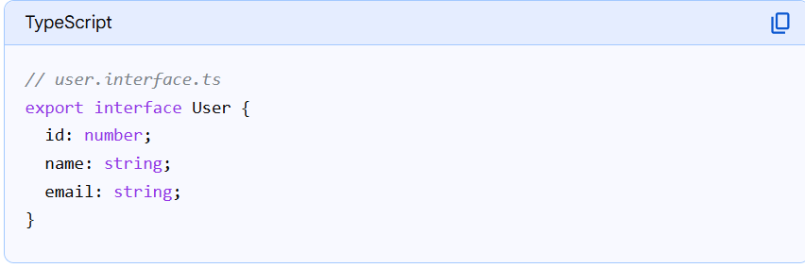
2.Create the Service with BehaviorSubject:
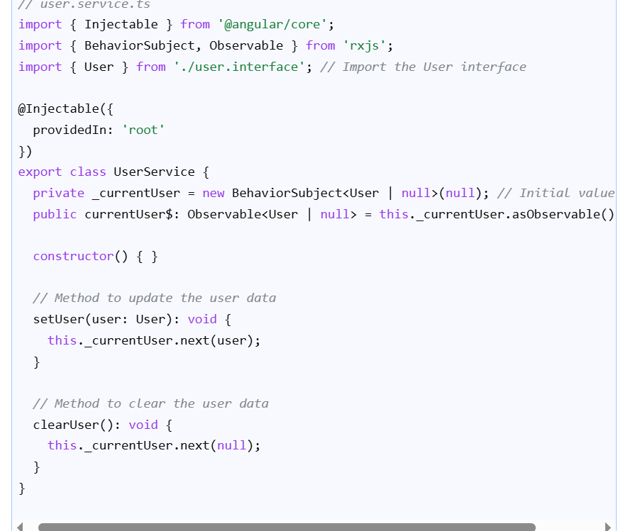

3. Consume the Service in Components:
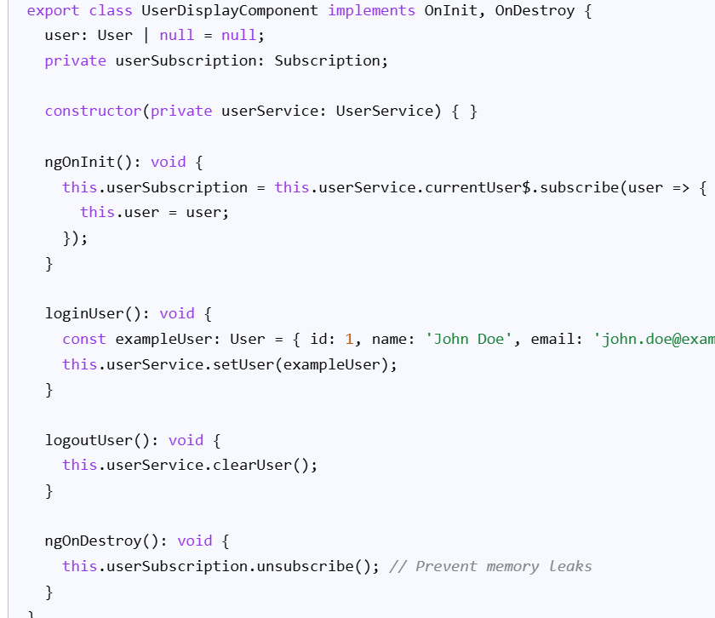

- Angular Signals (Angular v16+):
  - Angular Signals provide a reactive primitive for managing state directly within components or services.
  - You can create signal() or computed() values to represent your state.
  - Components can then directly access these signals or subscribe to their changes.
  - Signals offer fine-grained reactivity, leading to potential performance benefits.
TypeScript
// user.service.ts (using Signals)
import { Injectable, signal, computed } from '@angular/core';
interface User {
name: string;
age: number;
}
@Injectable({ providedIn: 'root' })
export class UserService {
private userSignal = signal<User>({ name: '', age: 0 });
// Expose a read-only signal or a computed signal
readonly user = this.userSignal.asReadonly();
readonly userName = computed(() => this.user().name);
setUser(user: User): void {
this.userSignal.set(user);
}
}
- Input/Output Properties (for parent-child communication):
  - For state shared between directly related parent and child components, @Input() and @Output() decorators are suitable.
  - Parent components pass data down to child components using @Input().
  - Child components emit events to parent components using @Output() and EventEmitter.
These approaches provide flexible and scalable ways to manage state in Angular applications without relying on external state management libraries like NgRx, especially for small to medium-sized applications or feature-specific state.

What is NgRx?
NgRx is a framework for building reactive applications in Angular. It provides state management using Redux patterns and RxJS observables.

1. Store
The store is a centralized container for your application state. It’s implemented as an RxJS observable, allowing components to subscribe to state changes. The store is immutable, meaning that the state cannot be changed directly — only through dispatched actions.

2. Actions
Actions are events that describe state changes in your application. They are dispatched from components or services and are processed by reducers to update the state. Each action has a type property and optional payload.

3. Reducers
Reducers are pure functions that take the current state and an action, then return a new state. They determine how the state changes in response to actions.

4. Selectors
Selectors are pure functions used to select, derive and compose pieces of state. They help in retrieving specific parts of the state from the store.

5. Effects
Effects handle side effects in your application, such as data fetching, long-running tasks that produce multiple events, and other asynchronous operations.

To prevent accidental navigation away from a form with unsaved changes in Angular, you can implement a CanDeactivate guard. This guard allows you to define logic that determines whether a route can be deactivated (i.e., whether the user can navigate away from the current component).

Fork Join Example:

import { forkJoin } from 'rxjs';
import { HttpClient } from '@angular/common/http';
// ... inside your component or service
constructor(private http: HttpClient) { }
fetchData() {
const users$ = this.http.get('/api/users');
const products$ = this.http.get('/api/products');
forkJoin([users$, products$]).subscribe(
([users, products]) => {
// 'users' will contain the last value emitted by users$
// 'products' will contain the last value emitted by products$
console.log('Users:', users);
console.log('Products:', products);
},
error => console.error('Error fetching data:', error)
);
}

Reactive Form Example:

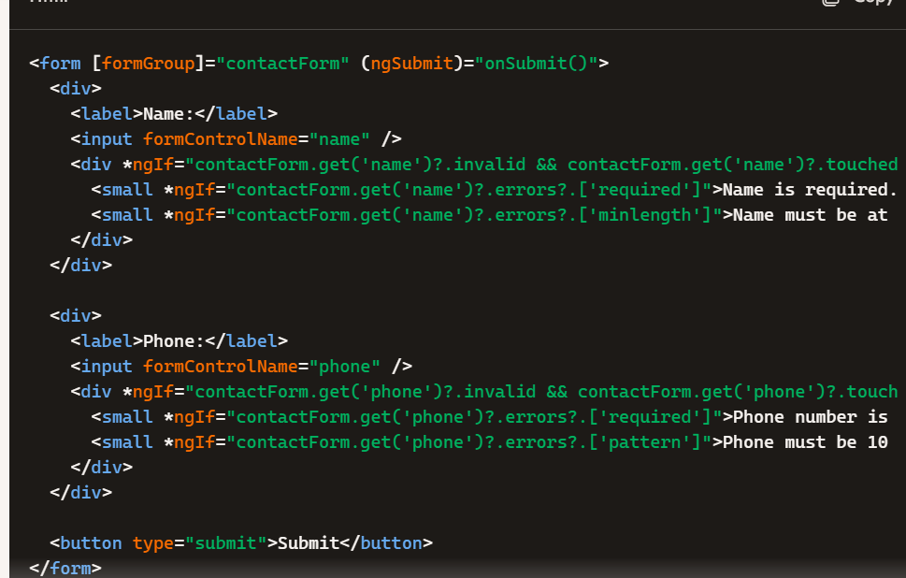

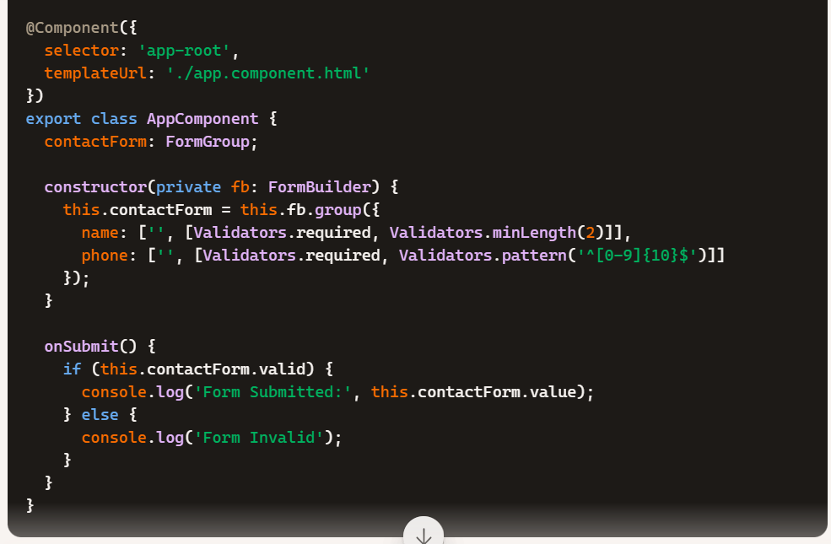

Template Drive Form Example

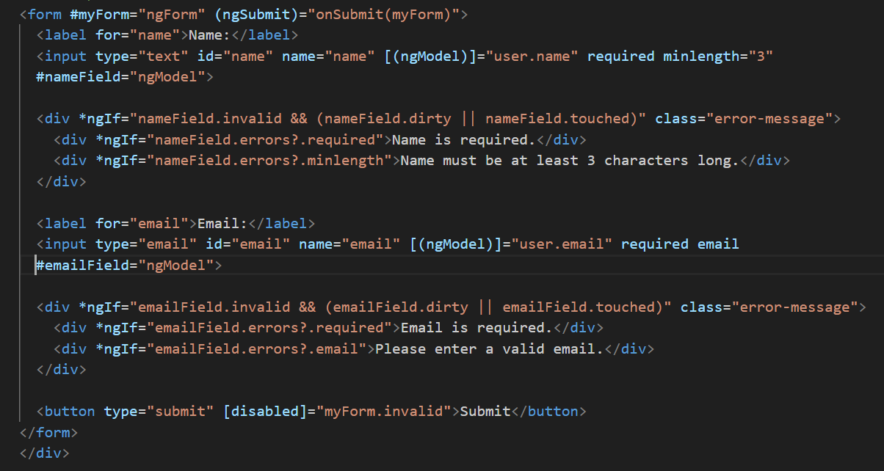

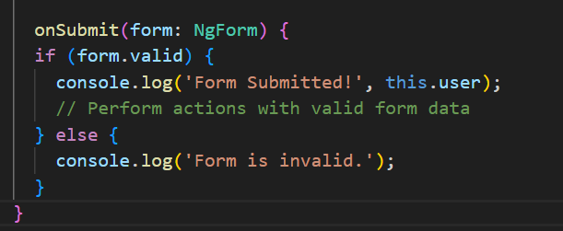

Explanation of Validation:
- HTML5 Validation Attributes:
Angular's ngModel directive integrates with standard HTML5 validation attributes like required, minlength, maxlength, pattern, and email.
- Template Reference Variables:
Assign a template reference variable (e.g., #nameField="ngModel") to individual input elements to access their validation state.
- ngModel Properties:
Use properties like invalid, valid, dirty, pristine, touched, and untouched of the ngModel instance to control the display of validation messages.
  - invalid: True if the control's value fails any validation.
  - dirty: True if the user has changed the value in the input.
  - touched: True if the user has focused on and then unfocused from the input.
- errors Property:
The errors property of ngModel contains an object with specific validation error keys (e.g., required, minlength).
- Conditional Display of Messages:
Use *ngIf to display validation messages only when an input is invalid and the user has interacted with it (e.g., nameField.invalid && (nameField.dirty || nameField.touched)).
- Disabling Submit Button:
Bind the disabled property of the submit button to myForm.invalid to prevent submission of an invalid form.

ViewChild:
It allows a parent component to directly access and interact with the public properties and methods of a child component or manipulate a specific DOM element.
Its commonly used for scenarios like: Accessing child component properties or methods. Manipulating the DOM, such as changing element content or styles.

What is the difference between @ViewChild and @ViewChildren in Angular?
Summary.
@ViewChild : For a single DOM element/component/directive.
@ViewChildren : For a list of multiple DOM elements/components/directives.

LoadChildren Example
const routes: Routes = [
{
path: 'items',
loadChildren: () => import('./items/items.module').then(m => m.ItemsModule)
}
];

Reactive form:

- Use setValue() when you have the complete data for all controls and want to replace the entire form value.
- Use patchValue() when you only have partial data and want to update specific controls without affecting others.

Map and Switch Map Example:

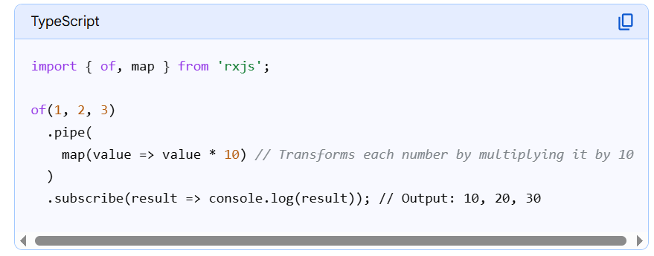

Switch Map Example:

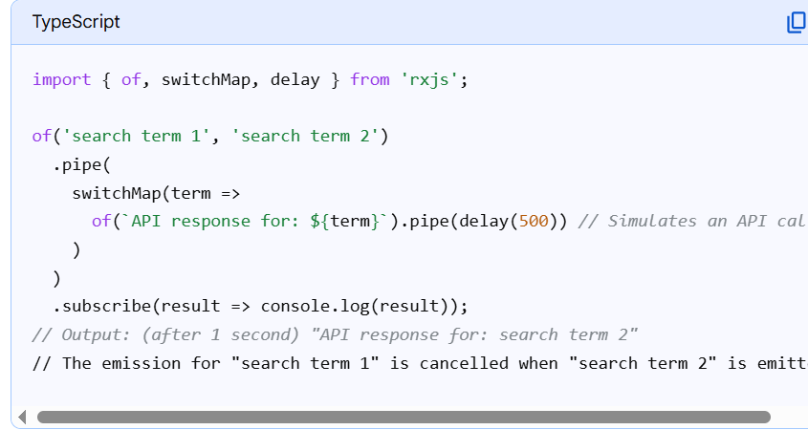

What is the main TS in Angular?
It serves as the application's entry point, responsible for bootstrapping the application and launching the root module in the browser environment.
main. ts is the starting point of every Angular application. It tells Angular to load AppModule, which then loads all components, services, and routing

What is a HostListener in Angular?
According to the official docs, the Hostlistener is a decorator that declares a DOM event to listen for and provides a handler method to run when that event occurs. Angular invokes the supplied handler method when the host element emits the specified event and updates the bound element with the result.

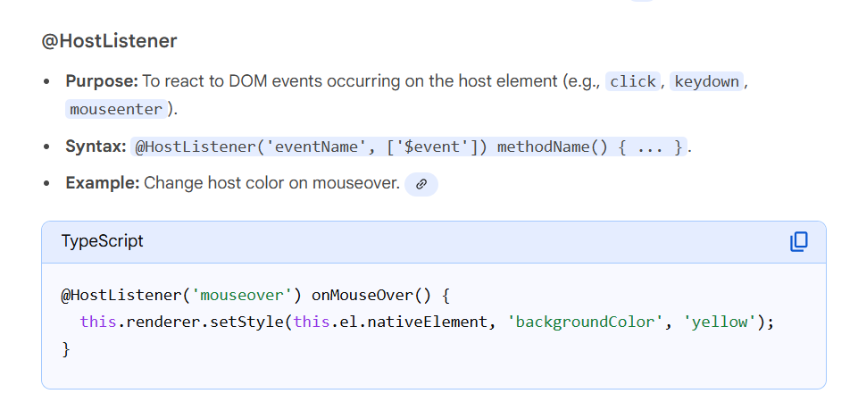

Key Difference
- HostListener: is for actions (events) happening to the host.
- HostBinding: is for attributes/properties of the host.

Change Detection in Angular:
In Angular 19, change detection is a mechanism that synchronizes the UI with the application's data state, primarily driven by Zone.js by default, but with significant enhancements and a push towards signals for fine-grained, zoneless reactivity.

Angular offers two main strategies to control this behavior:
- Default ( ChangeDetectionStrategy.Default ): The default behavior, where every component in the tree is checked during every change detection cycle.
- OnPush ( ChangeDetectionStrategy.OnPush ): An optimization strategy that tells Angular to only check a component (and its subtree) if one of the following conditions is met:
  - An @Input() property changes (by reference, not just internal mutation).
  - An event is triggered from within the component (e.g., a button click).
  - An observable consumed by the async pipe emits a new value.
  - Change detection is manually triggered using ChangeDetectorRef.

How to Optimize Angular application performance:
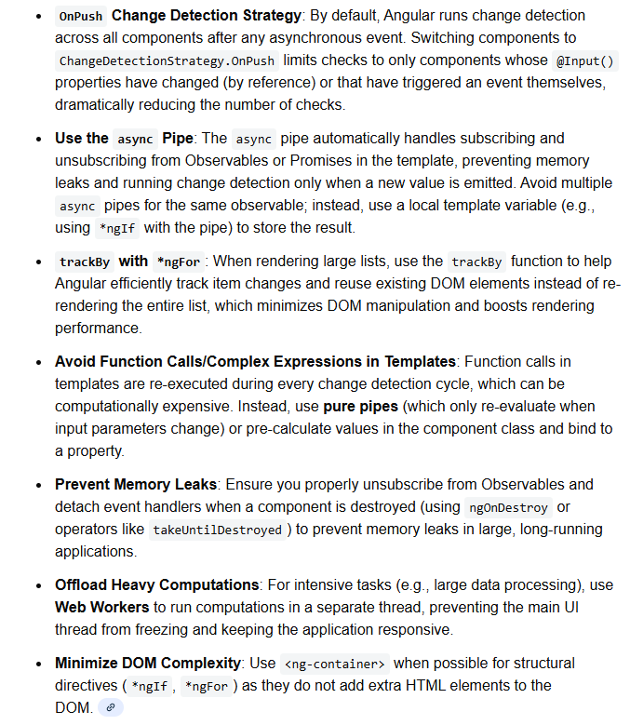

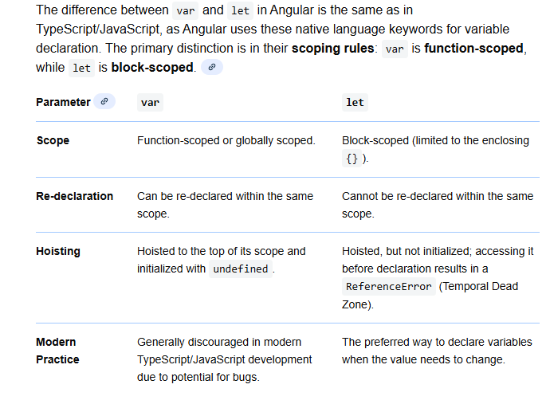

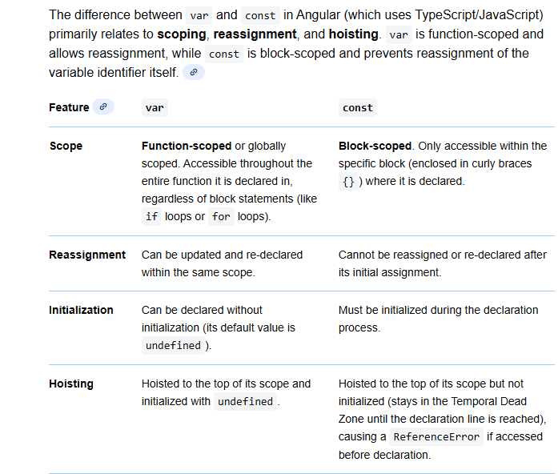

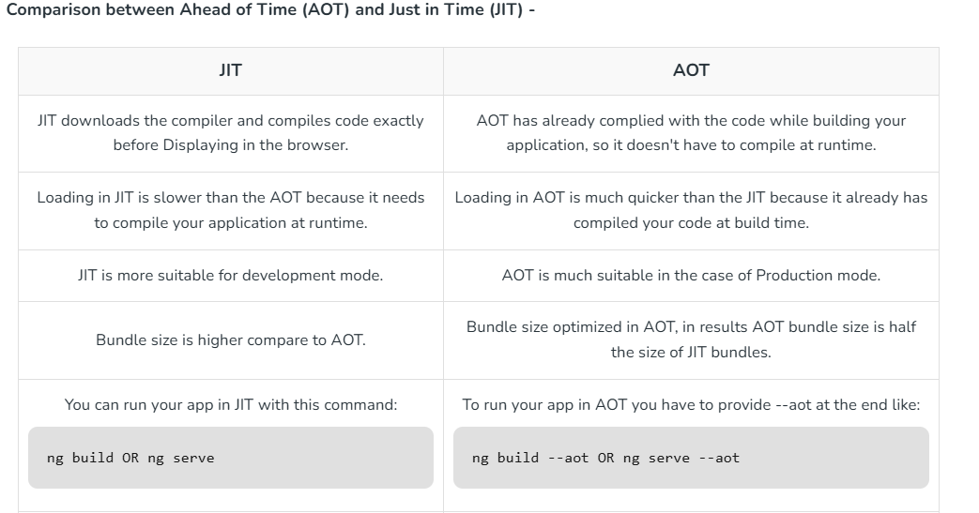

how to organized large scaled angular application:

1)Adopt Standalone Components and APIs
2)Structure by Feature, Not File Type
3)Use Route-Level Lazy Loading with Standalone Routing

4)Separate Core and Shared Concerns
Core: singleton services like auth, interceptors, global config.
Shared: reusable UI components, pipes, directives.

5)Manage State Wisely (NgRx + Signals)
Use Signals for local feature state.
Use NgRx (or Akita) for global app-wide state.

6)Maintain Clear Boundaries with Libraries
ui/ → reusable components
data-access/ → API clients, SDKs
util/ → helpers, pipes, validators

A custom Angular attribute directive can be created to format a US phone number as the user types, using the (XXX) XXX-XXXX pattern.
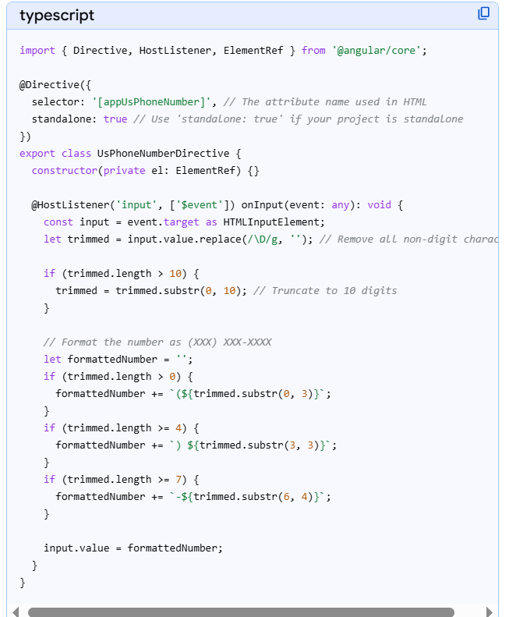

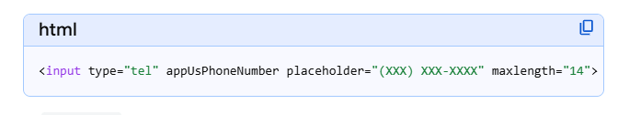

What is TypeScript:

TypeScript is widely used in Angular applications due to its scalability, maintainability, and tooling support benefits.

What is TypeScript?
TypeScript is a superset of JavaScript that adds static typing to the language. It allows you to specify types for variables, parameters, and return values, leading to improved code quality and error detection during development. TypeScript supports modern JavaScript features and integrates seamlessly with popular development tools like Visual Studio Code.

Role of TypeScript in Angular:
TypeScript plays a crucial role in Angular development as it is the recommended language for building Angular applications. It offers several benefits such as static typing, ES6+ features support, and seamless integration with Angular's features and APIs, making it the preferred choice for developing scalable and maintainable Angular applications.

Reason to use TypeScript in Angular:
- Static Typing: TypeScript provides static typing, allowing developers to specify types for variables, parameters, and return values, leading to improved code quality and error detection.
- ES6+ Features: TypeScript supports modern JavaScript features, including arrow functions, classes, modules, and destructuring assignments.
- Tooling Support: TypeScript integrates seamlessly with popular development tools like Visual Studio Code, offering features such as IntelliSense, code navigation, and refactoring support.
- Interfaces and Classes: TypeScript allows developers to define interfaces and classes, enabling better code organization and encapsulation.
- Compatibility with Angular: TypeScript is the recommended language for building Angular applications, offering seamless integration with Angular's features and APIs.
- Code Maintainability: With TypeScript, developers can write cleaner and more maintainable code by explicitly defining types and interfaces.

https://www.geeksforgeeks.org/angular-js/folder-structure-of-angular-project/

